# Basics

What are you minimizing = Cross-Entropy – distance between the two vectors – the softmax from the output layer and the expected one-hot encoding

Big picture (note no deep learning, just a simple NN). Take in the inputs X (matrix = size of samples * dimension or representation of each sample). Multiply by some linear model Weights * X + biases

Now take these scores (LOGITS) and covert them to probabilities using a softmax function

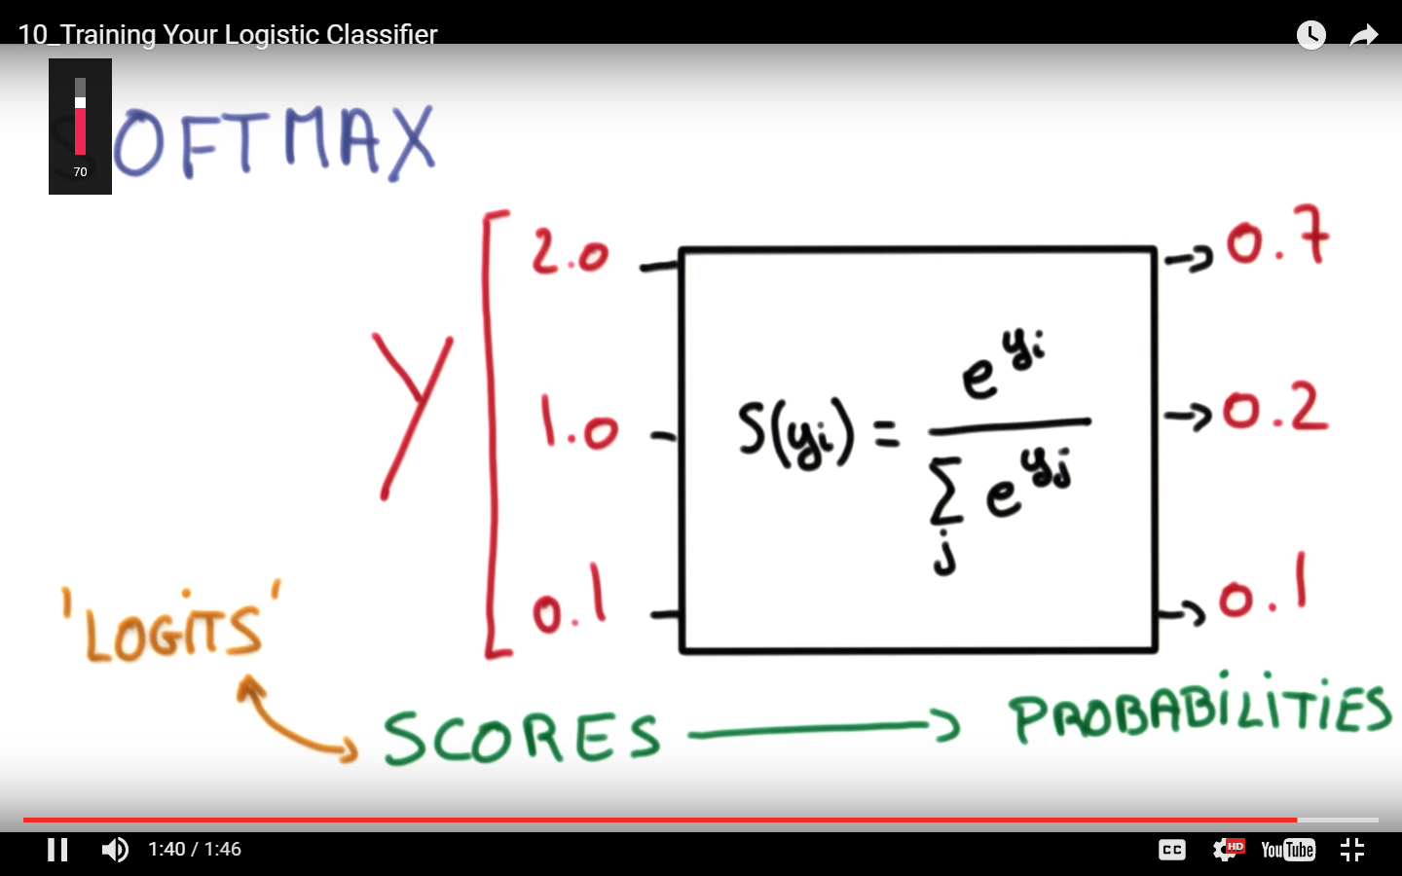

Bigger picture

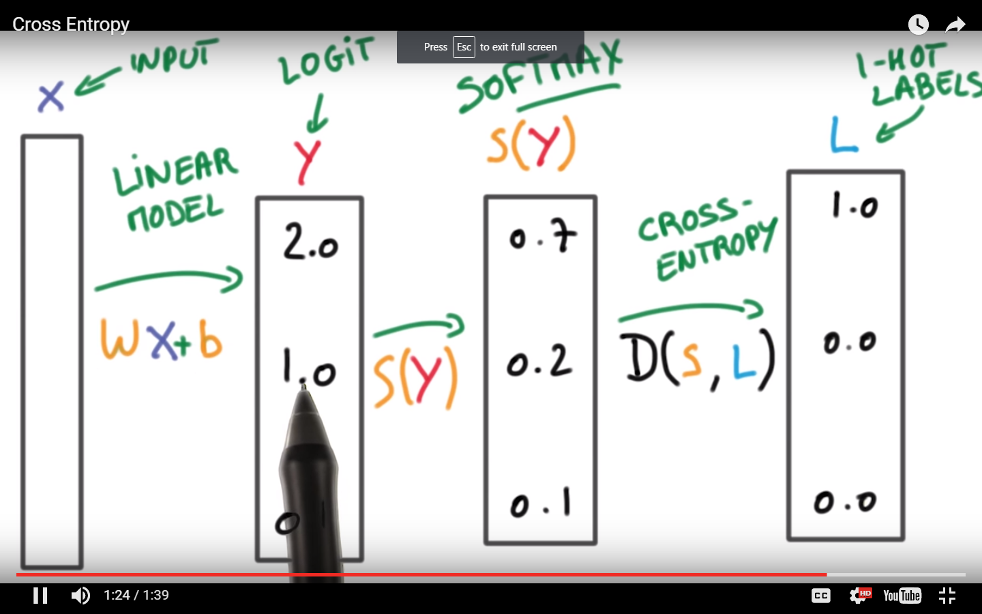

Where again cross entropy is the difference between the actual (one-hot encoding) w.r.t. what the model is telling you. You want to essentially minimize this loss throughout your sample size.

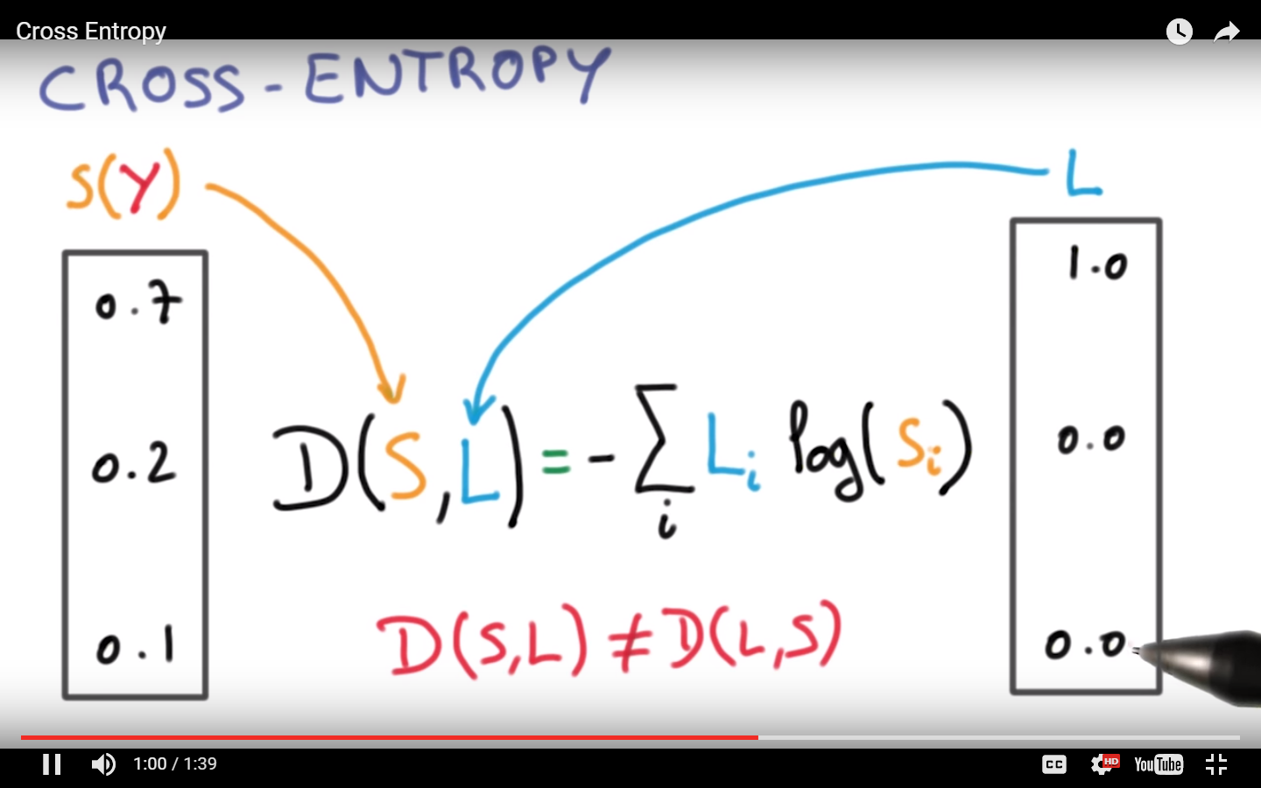

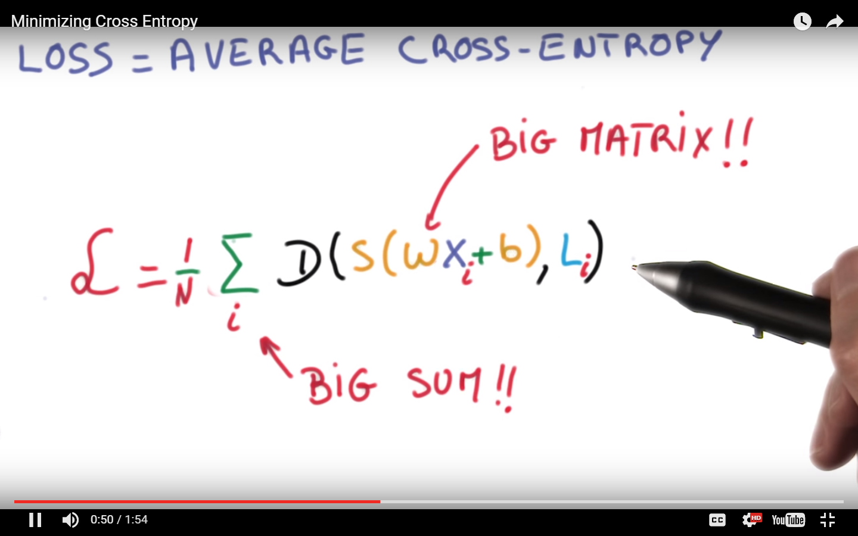

How do you do it – SCD – Stochastic Gradient descent

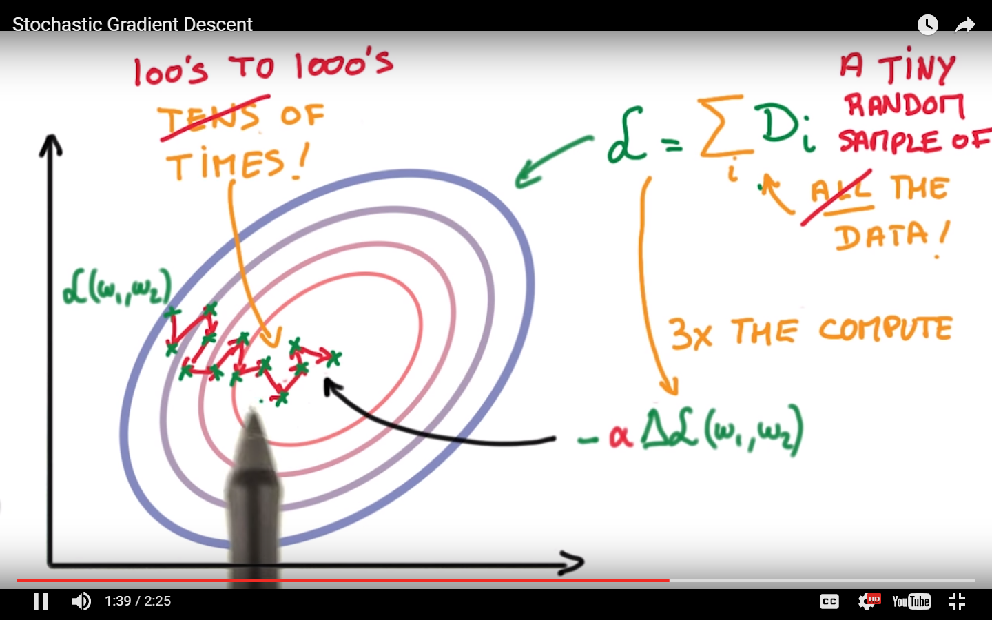

# Helping SCD

1. Inputs => Mean = 0 & Equal Small variance
2. Initial weights => Random, mean = 0, Equal Small variance
3. Momentum i.e. keep history of the past and then move accordingly.
4. Learning rate – slowly reduce it.
5. 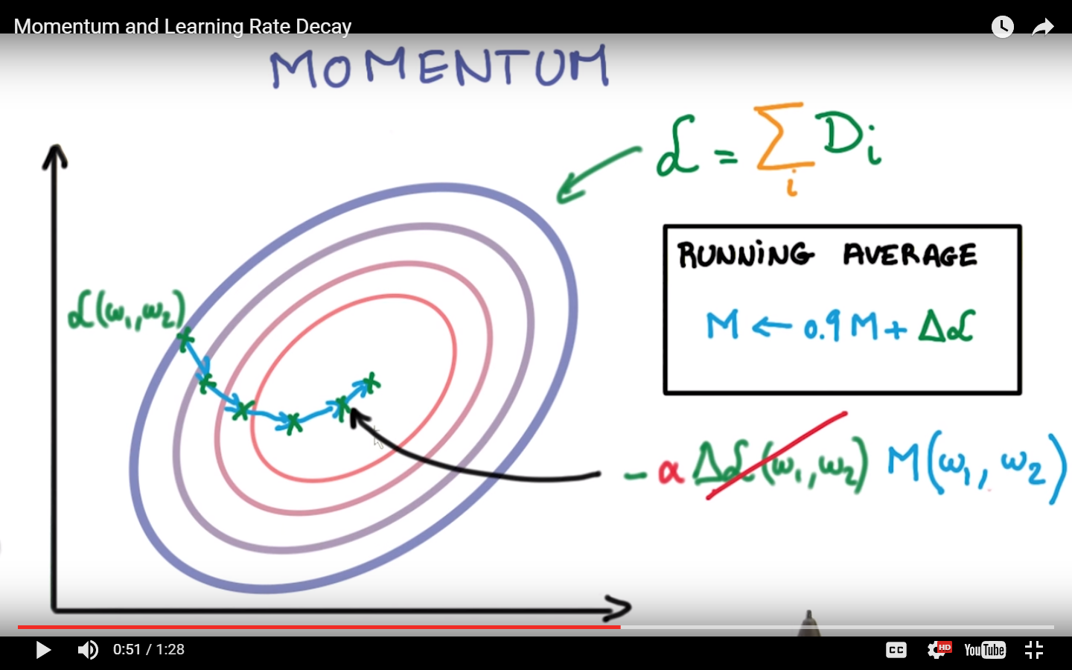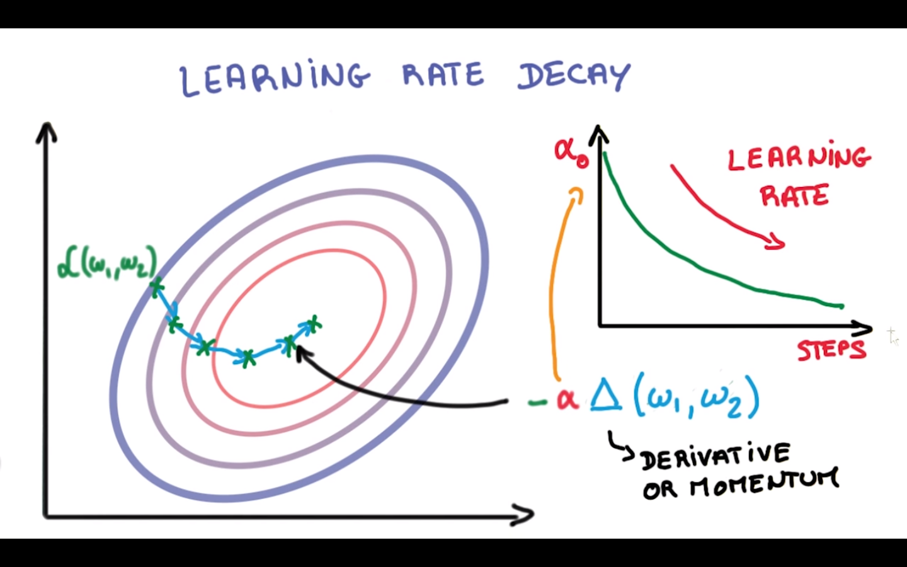

Final few pointers. “Adagrad” takes care of the first 3 but nothing beats hand tuned optimization.

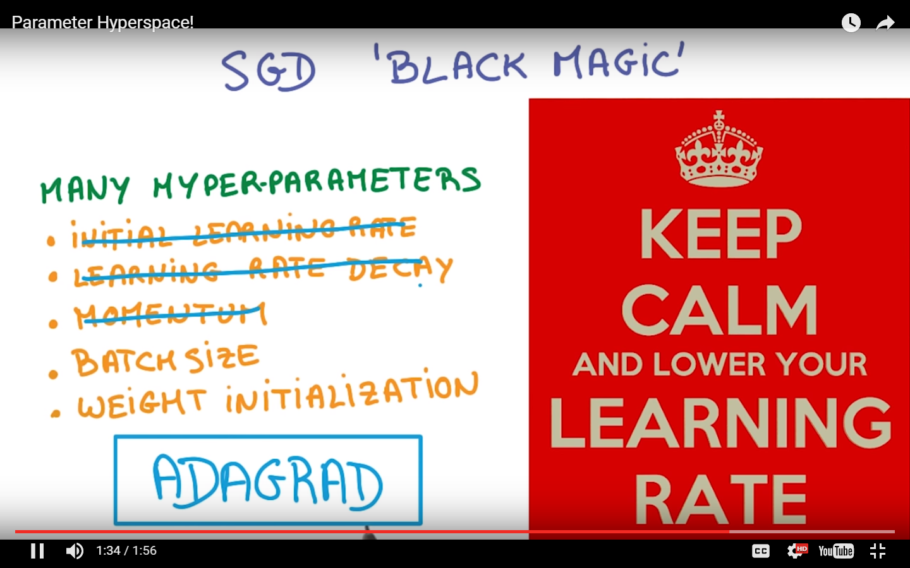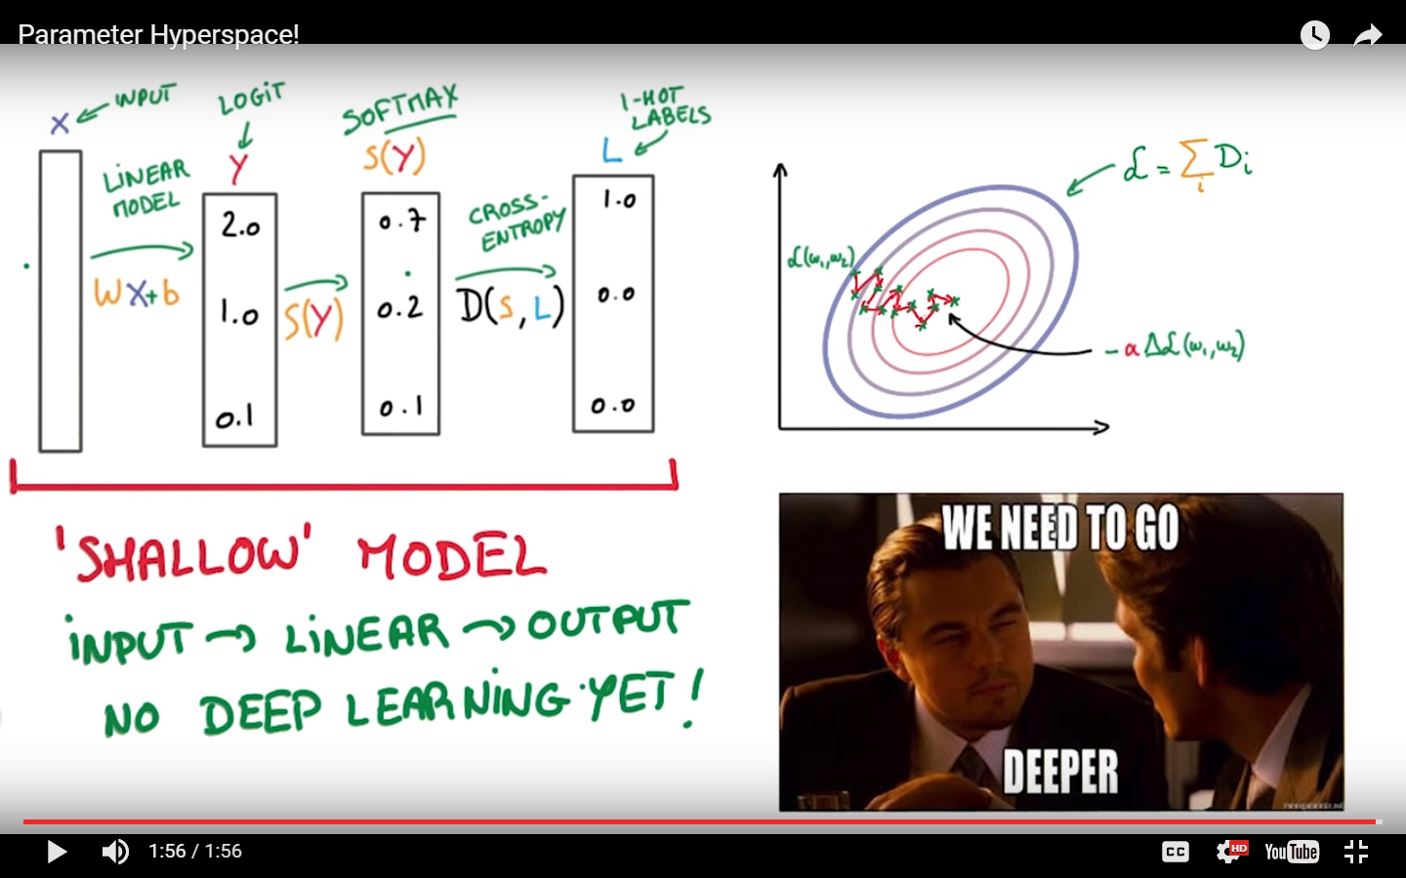

# Problem

Turn the logistic regression example with SGD into a 1-hidden layer neural network with rectified linear units (nn.relu()) and 1024 hidden nodes. This model should improve your validation / test accuracy.

### Linear model, with no RELU. Number of parameters (remember, the image size is 28 * 28. So X = N * (28*28) matrix. Hence, in the equation WX + b

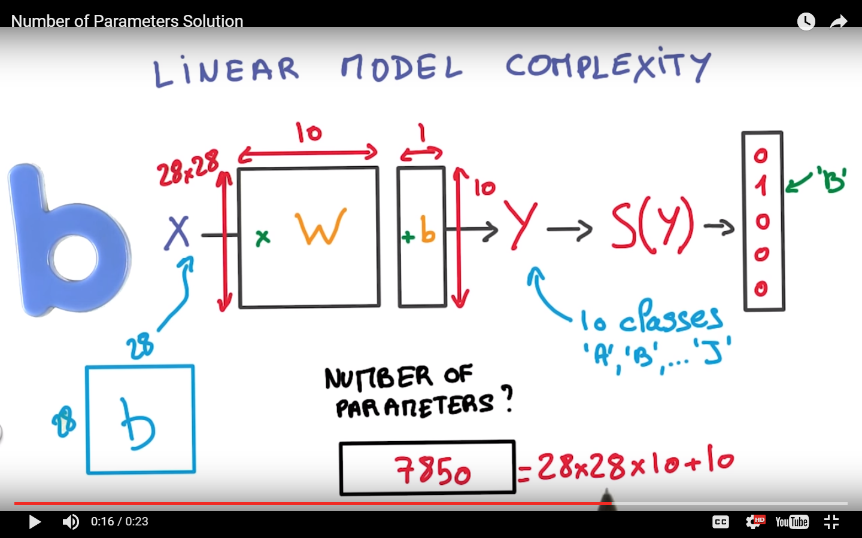

## Simple Non-linear function (sigma & tanh are others)

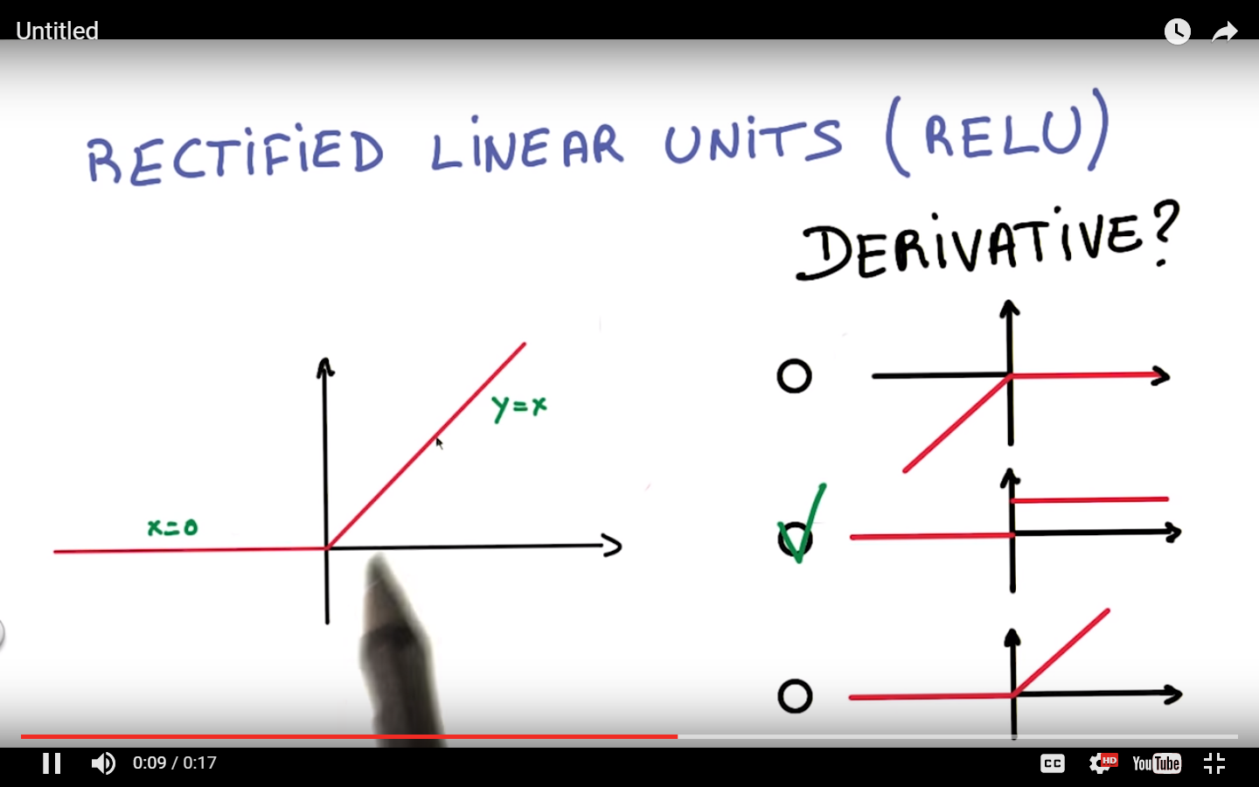

## Insert RELU

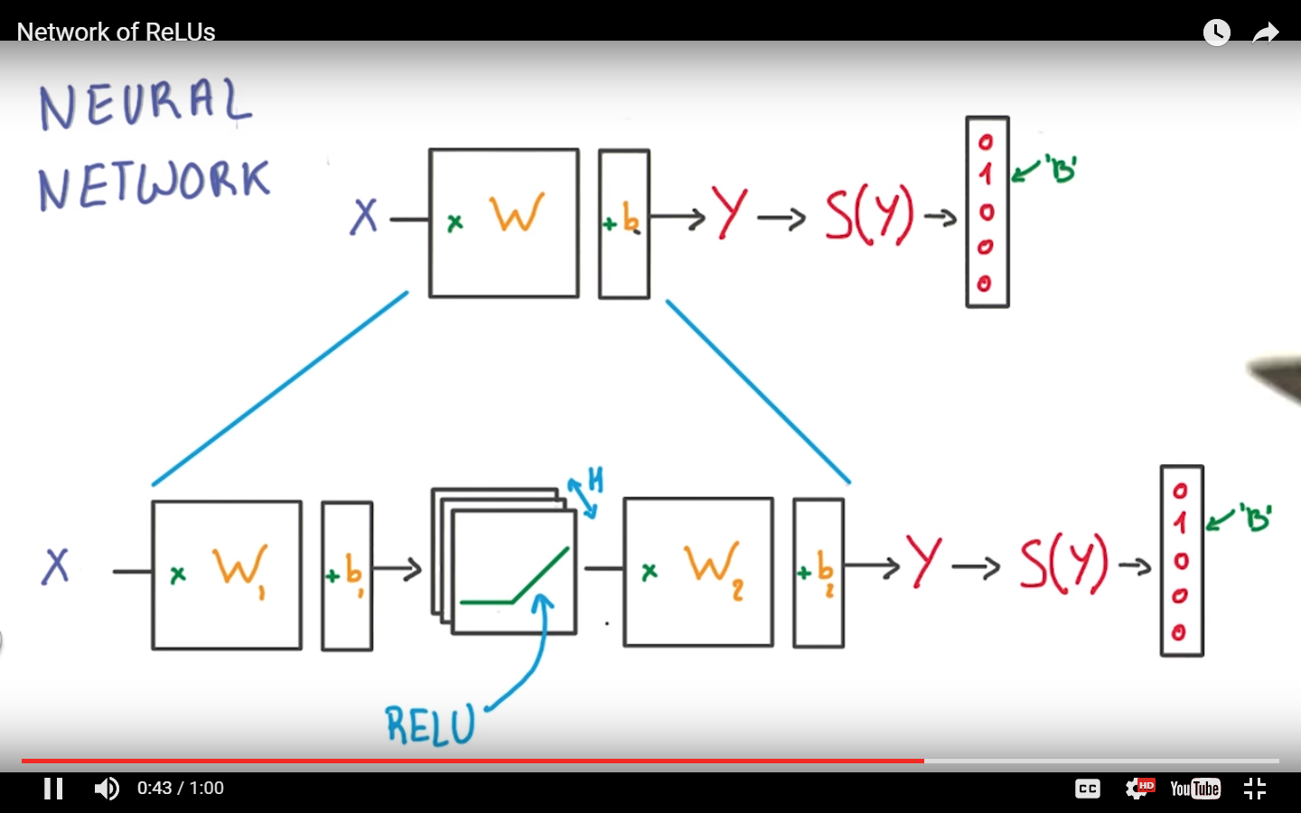

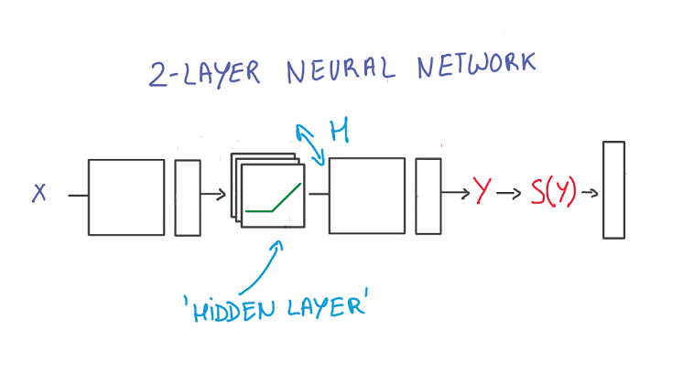

Note: Depicted above is a "2-layer" neural network:

1. The first layer effectively consists of the set of weights and biases applied to X and passed through ReLUs. The output of this layer is fed to the next one, but is not observable outside the network, hence it is known as a *hidden layer*.
2. The second layer consists of the weights and biases applied to these intermediate outputs, followed by the softmax function to generate probabilities.

Now, let’s look at the actual code + explanation for tensorflow.

//Turn the logistic regression example with SGD into a 1-hidden layer neural network with rectified linear units (nn.relu()) and 1024 hidden nodes. This model should improve your validation / test accuracy.

##START same as before

batch_size = 128

graph = tf.Graph() ##Now you create the structure in tensorflow, it’s a graph (generic structure)

with graph.as_default(): ##similar to using in c#, get the default graph. SO there can be more than one graph

# Input data. For the training data, we use a placeholder that will be fed

# at run time with a training minibatch.

tf_train_dataset = tf.placeholder(tf.float32, shape=(batch_size, image_size * image_size))

tf_train_labels = tf.placeholder(tf.float32, shape=(batch_size, num_labels))

#notice two kind of variables, constant that’s already bound and “placeholder” that will be bound

tf_valid_dataset = tf.constant(valid_dataset)

tf_test_dataset = tf.constant(test_dataset)

##END same as before

## START creation of new hidden layer

# new hidden layer, this is another **HYPERPARAMETER** that can be tuned.

hidden_nodes = 1024

## NOTE:: instead of num_lables you have this as 784*1024. And then later the weigths is 1024 * 10. Earlier, the weigths we 784 * 10

*## When you train a model, you use variables to hold and update parameters. Variables are in-memory buffers containing tensors. They must be explicitly initialized and can be saved to disk during and after training. You can later restore saved values to exercise or analyse the model.*

The difference is that with tf.Variable you have to provide an initial value when you declare it. With tf.placeholder you don't have to provide an initial value and you can specify it at run time with the feed_dict argument inside Session.run

hidden_weights = tf.Variable(tf.truncated_normal([image_size * image_size, hidden_nodes]) )

hidden_biases = tf.Variable( tf.zeros([hidden_nodes]))

hidden_layer = [tf.nn.relu](https://www.tensorflow.org/versions/0.6.0/api_docs/python/nn.html#relu)( tf.matmul( tf_train_dataset, hidden_weights) + hidden_biases)

# Variables.

weights = tf.Variable( tf.truncated_normal([hidden_nodes, num_labels]))

biases = tf.Variable(tf.zeros([num_labels]))

## END creation of new hidden layer

# Training computation.

logits = tf.matmul(hidden_layer, weights) + biases

## what is numpy axis -- http://www.sam.math.ethz.ch/~raoulb/teaching/PythonTutorial/intro_numpy.html

## example: 0 = rows, 1 = columns for 2 dimensional matrix.

## what does reduce mean do: <http://stackoverflow.com/questions/34236252/difference-between-np-mean-and-tf-reduce-mean-numpy-tensorflow>

## reduce mean = average mean across the axis or dimensions of the entire batch size.

loss = tf.[reduce_mean](http://stackoverflow.com/questions/34236252/difference-between-np-mean-and-tf-reduce-mean-numpy-tensorflow)( tf.nn.[softmax_cross_entropy_with_logits](https://www.tensorflow.org/versions/0.6.0/api_docs/python/nn.html#softmax_cross_entropy_with_logits)(logits, tf_train_labels) )

##maybe a better name for loss would be average_loss???

# Optimizer.

# 0.5 = learning rate

optimizer = [tf.train.GradientDescentOptimizer](https://www.tensorflow.org/versions/r0.10/api_docs/python/train.html)(0.5).minimize(loss)

# Predictions for the training, validation, and test data.

train_prediction = tf.nn.softmax(logits)

valid_relu = tf.nn.relu( tf.matmul(tf_valid_dataset, hidden_weights) + hidden_biases)

valid_prediction = tf.nn.softmax( tf.matmul(valid_relu, weights) + biases)

test_relu = tf.nn.relu( tf.matmul( tf_test_dataset, hidden_weights) + hidden_biases)

test_prediction = tf.nn.softmax(tf.matmul(test_relu, weights) + biases)

### same as before....

num_steps = 3001

with tf.Session(graph=graph) as session:

tf.initialize_all_variables().run()

print("Initialized all variables. ONLY do it ONCE for the session.")

for step in range(num_steps):

# Pick an offset within the training data, which has been randomized.

# Note: we could use better randomization across epochs.

offset = (step * batch_size) % (train_labels.shape[0] - batch_size)

# Generate a minibatch.

batch_data = train_dataset[offset:(offset + batch_size), :]

batch_labels = train_labels[offset:(offset + batch_size), :]

# Prepare a dictionary telling the session where to feed the minibatch.

# The key of the dictionary is the placeholder node of the graph to be fed,

# and the value is the numpy array to feed to it.

# PLACEHOLDER – bound to actual values in RUNTIME

feed_dict = {tf_train_dataset : batch_data, tf_train_labels : batch_labels}

_, l, predictions = session.run(

[optimizer, loss, train_prediction], feed_dict=feed_dict)

if (step % 500 == 0):

print("Minibatch loss at step %d: %f" % (step, l))

print("Minibatch accuracy: %.1f%%" % accuracy(predictions, batch_labels))

print("Validation accuracy: %.1f%%" % accuracy(

valid_prediction.eval(), valid_labels))

print("Test accuracy: %.1f%%" % accuracy(test_prediction.eval(), test_labels))